CGNET Team Members, in alphabetical order:
Abdulhakeem Abdulsalam

IT Consultant & Support Specialist
Hakeem is a dynamic technology acolyte with a wealth of experience in a variety of technology tracks including Infrastructure Design, Server Management, Systems Administration and Enduser Support. He is constantly leveraging the best use of technology to increase productivity in various lines of business and works extensively with Enterprise management and collaboration platforms such as Microsoft Azure, AWS, Office 365, Microsoft Lync/Skype for Business, Exchange and Active Directory.
Prior to working with CGNET, Hakeem provided support to several
organizations including Nigerian Sovereign Investment Authority (NSIA), Bureau of Public Procurement (BPP), Health Strategy and Delivery Foundation (HSDF). He strived to align IT with their business objectives and to create innovations that added significant operational value, while contributing to the organization’s bottom-line.
Over the course of his career Hakeem has amassed several professional certifications which include MCSA, MCSE, CCNA, MCT, CTT+ and VCP.

Josephine Andrews, Administrator
B.A., Accounting, Holy Cross of Davao College- Davao City, Philippines
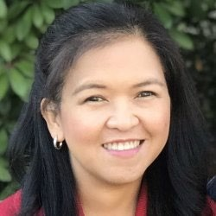
Josephine manages the business and financial activities of CGNET. These include accounting, accounts receivable, accounts payable, payroll, corporate tax, etc. She also manages employees’ medical insurance and retirement benefits.
Josephine has many years of accounting experience, working for Bank of
America Savings Bank, the Institute of Primary Health Care, Davao Light & Power Company and the Development Agency Institute, which is a non-profit organization. Josephine speaks fluent English, Tagalog and Visayan.

Stella Simon Asomugha, IT Consultant & Support Specialist

B.Tech, Computer Science – Modibbo Adama University of Technology, Yola, Nigeria
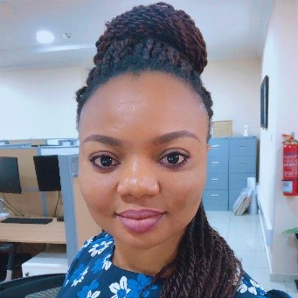
In security, Stella’s experience includes switched network & router security, hardware/software firewalls (ASA/5500 & MS-ISA server), hacking and countermeasures, 802.1x, wireless security, network systems security, patch & vulnerability management, PKI, VPNs, and Cisco IOS Security tools.
Stella’s skills in networking include basic to complex (IGPs & BGP) TCPIP & IPv6 networking, frame-relay, policy-based routing traffic engineering, QoS, multicasting, NAT/PAT, 1700/2500/3600 modular Cisco Routers, L-2 / L-3
switching, stacked / P-VLANs, ether channels, 1900/2900/3500 Cisco switches & APs, HSRP (other IOS features), and WAN Optimization with Riverbed Steelhead Appliances.
Before assuming her role as CGNET Technical Support for the Bill and Melinda Gates Foundation in Abuja, Stella worked for the Infrastructure Concession Regulatory Commission (ICRC) and the Federal Radio Corporation of Nigeria. She speaks English, Ingbo and Hausa fluently.

Kishore Bhargava, Senior Technology Consultant

B.S., The University of Delhi
Kishore is responsible for System Administration, Facility Management, Network Administration, Security, System Design, and Training. He has covered several regions for CGNET, including South and South-East Asia, East and West Africa, USA and China. Kishore managed entire IT departments (from 250-1500 users) for CGNET clients in Indonesia, Philippines, and Kenya. He has also provided on-the-ground support to many of CGNET clients including the Ford Foundation, Packard Foundation, Family Health International (FHI), CARE, Center for International Forestry Research, International Rice Research Institute, International Development Research Center, International Crops Research in Semi-Arid Tropics, International Fund for Agricultural Development and many others.

Outside his work with CGNET, Kishore is also a contributor to a domestic newspaper, and describes himself as a “confirmed geek, wanna-be photographer, perpetual learner, FOSS fanboy, and aspiring coffee snob”. He is fluent in both English and Hindi.

Jacqueline Bilodeau, Communications Director

B.A., Stanford University, Sociology/Social Sciences
Jackie manages CGNET’s external communication streams including website design and content, social media, newsletters, blogs, media campaigns and customer relationship management systems.
Jackie has returned to CGNET last year after serving from 1991-2002 as the Client Support Coordinator, where she acted as a liaison between IT support staff and clients. In her current position, Jackie is responsible for the creation, production and distribution of informational and promotional materials to existing and prospective customers, administration of the CGNET
website, writing and editing blogs, and other writing and editorial activities (proposals, service contracts, human resources documents, etc.) as needed.
During her years away from CGNET as a stay-at-home mom, Jackie was very active in volunteer work involving community hunger issues. She served as the co-coordinator of a food pantry, assisting with all daily operations and management. Jackie helped modernize the 30-year-old pantry by setting up its first client database, enabling the generation of client demographics and participation statistics. She managed monthly procurement, delivery and handling of food items from the county food bank and donors, organized student and adult volunteers, wrote grant proposals and oversaw special events.

Liliana Bravo, Senior Systems Engineer

B.S., Systems Engineering, University Nacional del Callao, Peru
Liliana has 16 years’ experience on various Microsoft platforms including AD. She has undertaken a dozen migrations to Office 365 and has worked on very complex AD structures of up to 12,000 people. Prior to CGNET, Liliana worked for nine years as System Administrator of the International Potato Centre in Lima, Peru. Liliana holds Microsoft Certified Professional status in messaging, communications and cloud services. She is fluent in Spanish and English.

Daniel Callahan, Vice President, Global Services

M.S. Management, MIT Sloan School of Management
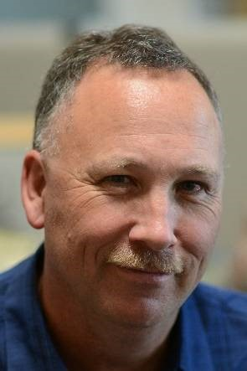
Dan is responsible for development of CGNET’s cloud and cyber security services. He oversees all aspects of CGNET’s Office 365, Teams/Skype for Business, Azure, Enterprise Mobility + Security and Dynamics CRM Online cloud services. He is responsible for CGNET’s vulnerability testing projects as well as GDPR compliance, risk assessment and security consulting services.
As a consultant, Dan has conducted many technology planning, change management and tool selection projects for customers including the World Food Programme, Energy Foundation, PYXERA Global, the Kenneth Rainin Foundation, Lemelson Foundation, Surdna Foundation, Marin Community Foundation, the Stuart Foundation, Education Pioneers, Wilburforce Foundation, the California Wellness Foundation, Clinica Sierra Vista, ClimateWorks Foundation, the Duke Endowment Fund, the Ludwig Institute for Cancer Research and Carnegie Hall.

Dan served as Director of Marketing and Business Operations at CGNET from 1999 to 2003. Prior to rejoining CGNET in 2011, he held Director and VP positions in Product Management and Marketing at iPass (acquired by Parateum), SOMA Networks, Daintree Networks (acquired by GE) and YouSendIt (acquired by OpenText). He has been responsible for product lines generating up to $100 million in revenue. He has managed large-scale systems software projects and specified requirements for software supporting millions of concurrent user sessions. Dan’s undergraduate degree is in Anthropology from Stanford University.

Abiy Alemu Eticha, IT Consultant & Support Specialist

B.S., Computer Science, HiLCoE School of Computer Science & Technology

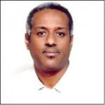
Abiy has been with CGNET for over 6 years, as a consultant on assignment for the Packard Foundation and the Bill & Melinda Gates Foundation. Abiy has been in the IT field for over 12 years and continues to gain valuable knowledge in his field and the certifications and training necessary for him to flourish as an IT Consultant & Support Specialist.

Timothy Haight, Vice President, Technology Services

Ph.D., Communication, Stanford University

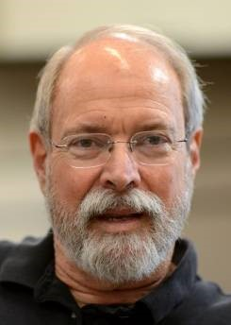
Tim has been studying how nonprofit organizations can optimize their use of information technology for more than 30 years, since he was the first evaluator for Apple Computer’s Community Affairs Program. He has been at CGNET since 2002 and conducted a great number of organizational analyses.
Tim has done assessments and strategic plans for the Marin Community Foundation, Metta Fund, the Houston Endowment, ClimateWorks Foundation, the California Wellness Foundation, the Carnegie Corporation of New York, Bush Foundation, Africa Reinsurance Corporation, Stuart Foundation, Annie E. Casey
Foundation, the World Bank (CGIAR), Partners in Population and Development,
FAO, the Women’s Funding Network, Britain’s Department for International Development, Canada’s International Development Research Center, the California Healthcare Foundation, the Oregon Community Foundation and the Robert Wood Johnson Foundation.
Prior to CGNET, Tim was Editor-in-Chief of FTPOnline, Vice President of Communications at OneChannel, Executive Editor of Network Computing, and West Coast Bureau Chief of CommunicationsWeek. Early in his career, Tim served on the faculties of the University of Wisconsin-Madison and California State University, Los Angeles. Tim also holds a B.A. from Stanford University.

Richard Hsu, Systems Engineer

B.S., Computer Science with Concentration in Engineering, Cal State Hayward (East Bay)

Richard specializes in network storage, routers, switches and operating systems. At CGNET, he is a part of our engineering team and supports customers worldwide. Prior to joining CGNET, Richard provided various IT services to Celeros Corporation, the California State Automobile Association and Phillips Semiconductor.

Amit Kalra, Senior IT Consultant

B.S., Math, SGTB Khalsa Collage, Delhi University
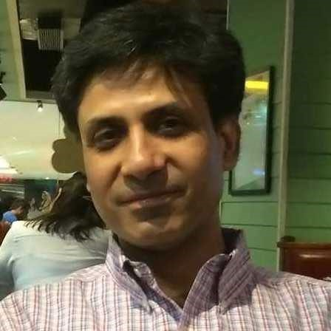
Amit Kalra has 20 years of experience in IT support. After graduating with a degree in math, he returned to school for a 2-year postgraduate program, where he obtained an advanced degree in Computers from NIIT, New Delhi.
He began his career in television as a 3D animator and video editor, and later was involved in the direction and post production of tv shows. After coming to the realization that he preferred the technical aspects of his work more than the creative, he decided to change careers and moved into IT.
His many years of on-the-ground experience include handling complete IT support for media outlets, international law firms, international institutes and various small-to-medium sized organizations. Amit has coordinated the complete IT infrastructure set-up for new offices including voice and data cabling, installation of wireless systems, firewalls, UTMs and Servers. He specializes in setting up enterprise wireless systems, SAN and NAS storage systems. He also manages cloud-based services and servers.
Amit heads a team of people who can provide efficient remote and onsite IT support in India. He is fluent in English, Hindi and Punjabi.

Georg Lindsey, Chief Executive Officer

Ph.D., Communication, Stanford University
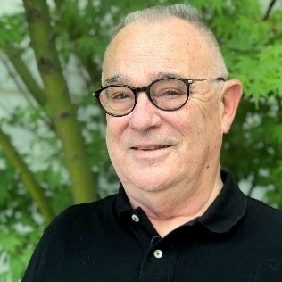
Georg co-founded CGNET in 1983 as a sustainable organization that would keep its clients at the leading edge of practical information and communication technology, with an emphasis on networking, messaging and collaboration. He has overseen and undertaken IT infrastructure designs and installations in Europe, Africa, Asia, North America, South America, and Australia. His on-theground experience includes working with scores of international organizations and foundations including Gates Foundation, Ford Foundation, African Development Bank, UNDP, UNEP, World Bank, IFAD, USAID, US Department of Agriculture, and many more.
Prior to CGNET, Georg worked for Nortel Networks’ R & D laboratory, Bell Northern Research. Georg has undertaken consulting assignments for the Rand Corporation, SRI International, NASA, NSF, Los Alamos National Scientific Laboratories, National Institutes of Health, KQED Television, UCLA, UCBerkeley, University of Southern California, Stanford University, the Food and Drug Administration, and many others. Georg also holds a B.A. and M.A. in Communication from San Jose State University.

Carol Martinak, Strategic Planning Specialist
BBA, Management Information Systems, CUNY

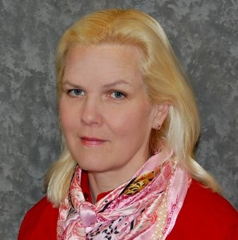
Carol recently rejoined CGNET as a Strategic Planning Specialist. Prior to returning to CGNET, she worked in various capacities for The Access Group for several years, eventually serving as the Vice President of IT. There she crafted and maintained cost-effective leading-edge adoption of new technology for sales force, office staff and network. She previously worked for CGNET from 1998-2004 in the capacity of Global Email Administrator for the Ford Foundation in New York City, one of CGNET’s largest customers.

Ali Marzouq, IT Consultant & Support Specialist B.S., Information Technology, Damascus University

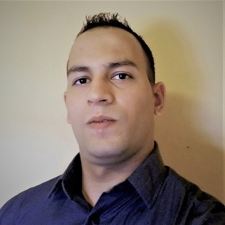
Ali provides IT support service to CGNET clients in Charlotte, NC. Prior to joining CGNET, Ali was responsible for the installation and repair of WAN/LAN and wireless access point (WAP) related equipment, and the installation and maintenance of wifi network products including routers, gateway servers and ethernet switches. Ali is experienced in various operating systems, including Apple and Android, as well as firewall systems, VPN design, network/host level security and Windows Active Directory.

Murtdaha Marzouq, IT Consultant & Support Specialist

Central Piedmont College, University of North Carolina, Charlotte
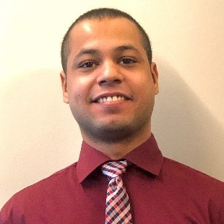
Murtadha Marzouq (Abu) is an IT specialist with over 4 years of experience in IT infrastructure and networking. Murtadha graduated from Central Piedmont College and currently is a student at The University of North Carolina in Charlotte. Murtadha provides IT support for our clients in Charlotte, NC. He is experienced in setting up IT infrastructure from Cisco networking to Active Directory. He also has experience in Linux and setting up Linux-based services such as Secure FTP, MySQL and Apache web server. Murtadha was born in Damascus, Syria and has been in the United States for 10 years.

Zerihun Negash, IT Consultant & Support Specialist

Information Technology Specialist, St. Mary University

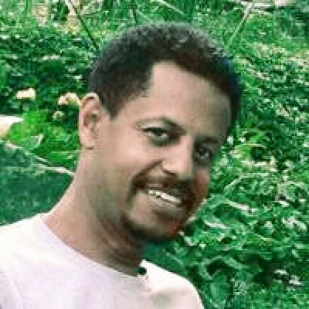
Zerihun has over 20 years of IT experience working for various companies and organizations of all sizes. Zerihun has managed the installation and configuration of Windows Server and Microsoft Outlook systems for individual users, and has facilitated ICT development. Zerihun handles many facets of IT, from management to system backups. Zerihun now works with CGNET Services International as an Information Technology Specialist at client locations in Ethiopia.

Dante Palacios, Global Services Manager

B.S., Computer Science, University of Lima
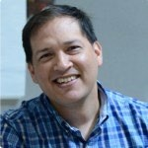
Dante has supported Microsoft mail products for 11 years and Active Directory since its inception. Dante undertakes client redesigns, upgrades and migrations to advanced platforms such as Office 365, Azure, and AWS. Prior to CGNET he worked for the International Potato Center in Lima. Dante is a VMware Certified Professional, a Microsoft Certified Professional and has undertaken continuing studies at Stanford University. He is fluent in Spanish and English.

Kadir Salami, Senior IT Consultant

M.S., Information Technology, Ladoke Akintola University of Technology

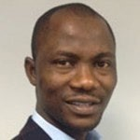
Salami provides IT management and support to CGNET clients in Africa and Europe. Salami has extensive experience in IT support and development particularly in Nigeria. He heads the consulting firm, Techspecialist
Consulting Ltd., and provides system and network administration services to the United Nations Office on Drugs and Crime, the Bill and Melinda Gates Foundation, and Quanteq Technology Services. Salami also hold a B.S. in Engineering from the University of Ilorin.

Samuel Taddese, IT Consultant & Support Specialist

MSc. Information Systems, Addis Ababa University
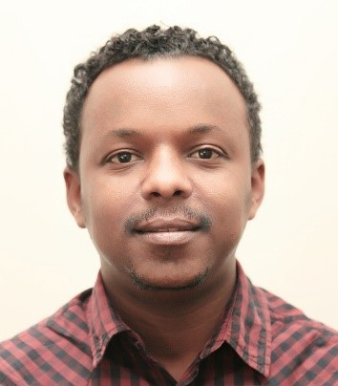
Samuel has been with CGNET since February 2019 as IT Consultant and
Support Specialist on assignment at Bill & Melinda Gates Foundation and PACKARD Ethiopia Offices. In this role, Samuel coordinates IT management and supports staff. Prior to joining CGNET, Samuel was working in ILRI as an ICT Infrastructure Officer, ICT Endpoint Officer and ICT Customer Services
Officer where he acquired vast knowledge and skill in ICT support, Project
Management and Systems Development. He has also worked with GOAL, USAID and a government university as IT Support, Consultant and Instructor respectively.

Lonni Ton, Administrative Associate

B.S., Computer Science, Sacred Heart University
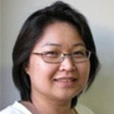
Lonni is responsible for Accounts Receivable at CGNET, as well as administrative duties including travel logistics for CGNET staff.
Prior to this position, Lonni lead CGNET’s 24/7/365 team that was responsible for monitoring, troubleshooting, documenting and escalating any CGNET network-related problems. She also provided advanced technical support and was responsible for the maintenance and administration of AntiVirus, Monitoring, Documentation, and Backup systems. Before joining CGNET, Lonni
owned and managed her own business and worked as a network administrator at Microphase Corporation and a PC support technician at Nash Engineering. She is fluent in Vietnamese and English.

Ricardo Uribe, Chief Technology Officer

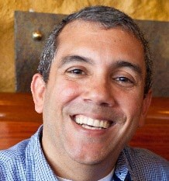
B.S., Computer Science, Oregon State University
Ricardo has overall responsibility for technology systems, design, implementation and R & D. He is responsible for supporting CGNET clients in fifty countries.
He has conducted strategic ICT consulting and assessments for the World Conservation Union, Carnegie Corporation, Duke Endowment, University of the Virgin Islands, FAO, the Africa Rice Center in Cotonou, Benin, the International Institute of Tropical Agriculture in Ibadan, Nigeria, the African Development Bank, the Robert Wood Johnson Foundation, the Annie E. Casey Foundation, and many others.

Ricardo has served and currently serves as the virtual Chief Technology Officer at several Silicon Valley startups and foundations including Sonitus Technologies, uLabs Systems and Metta Fund. He oversees the local IT support of the Bill and Melinda Gates Foundation offices in Beijing, New Delhi, Abuja, Addis Ababa, and Johannesburg.

Ricardo joined CGNET in 1999 after working for seven years at the International Center for Tropical
Agriculture (CIAT) in Colombia in the GIS department, and later in the Information Systems Unit as Network and Computer Administration Manager, User Support Manager, and Acting Chief Information Officer. Ricardo is fluent in Spanish and English.

Veronika Villarreal, Administrative Assistant

B.S. Systems Engineer, University of Lima
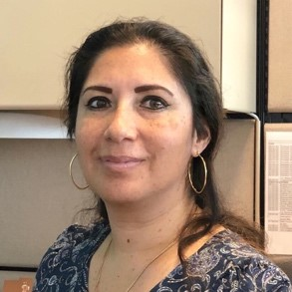
Veronika recently joined CGNET as an Administrative Assistant, working with the A/R and A/P departments as well as providing general clerical duties for the company.
Prior to CGNET, Veronika worked in Sales with Editrade and Oracle, and as an Autodesk Product Manager for Sams. She joins our team after spending several years as a stay-at-home mom and volunteer in her community. Veronika is fluent in Spanish and English.

Colin Webster, Senior Technical Advisor

B.A., Honors, Geography, Computer Studies, Edge Hill College of Higher Education – Lancaster University

Former IT director of the International Center for Research in the Dry Areas (ICARDA) in Aleppo, Beirut, and Aman, Colin is an ICT Consultant with 25 years extensive International Information Technology knowledge and experience. He has worked with and visited a majority of the CGIAR international centers in a dozen countries. He works daily with Packard Foundation offices in Addis, Karachi, and Delhi. We recently completed an assignment for the World Food Program which involved the migration of 15,000 mailboxes from on-prem to Office 365.

Colin is a certified as Information Security Manager (CISM) by ISACA (Information Systems Audit and Control Association). He is skilled in developing and maintaining a broad vision and cultivating excellent working relationships within an organization. Colin works with clients to assess their current IT situation, delivering expert insight and robust recommendations that strengthen management decision-making.

