CGNET Team Members, in alphabetical order:

Grace Uche Alubari, IT Consultant & Support Specialist
B.Eng. in Electrical and Electronics Engineering, Federal University of Technology Owerri, Imo State, Nigeria
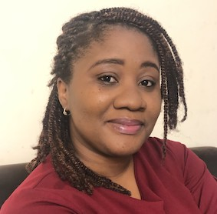
Grace has several trainings and certifications in Cloud Computing and Cyber Security, and numerous professional trainings including: Maintaining and Troubleshooting Windows Vista Computers (MS5118), Microsoft Certified Professional MCP, Microsoft Certified Solutions Associate (MCSA) and Installing and Configuring for Windows7 (MS70-680 and70-685) IT Infrastructure Library (ITIL V2.0).
Grace holds a Post Graduate Diploma in Project Management from the University of Liverpool and has contributed greatly to IT projects for a multinational company in the oil and gas industry. These ranged from operating systems migrations (2009), Microsoft Office Suites upgrades, software deployment and several adoptions of remote working tools -MOP, MOB, DTAO, Remote Access and Global Protect. She also worked part-time as Project Coordinator for Desk Phones to Soft Phones Migration Project (2014) across countrywide locations.
Before assuming her role with CGNET Technical Support for the Bill and Melinda Gates Foundation in Abuja, Grace worked as an IT Support Analyst for the Central Service Desk in Shell Petroleum and Development Company (SPDC) in Port-Harcourt for 11 years.
Grace is passionate about providing great customer experience, focus-driven on successful project completion. She enjoys creative writing, particularly short stories and poetry. She is an adamant believer that every human has a pot of gold in them. She speaks Igbo, Hausa and English fluently, and has a good working knowledge of ASL.

Josephine Andrews, Administrator
B.A., Accounting, Holy Cross of Davao College- Davao City, Philippines
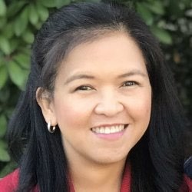
Josephine manages the business and financial activities of CGNET. These include accounting, accounts receivable, accounts payable, payroll, corporate tax, etc. She also manages employees’ medical insurance and retirement benefits.
Josephine has many years of accounting experience, working for Bank of
America Savings Bank, the Institute of Primary Health Care, Davao Light & Power Company and the Development Agency Institute, which is a non-profit organization. Josephine speaks fluent English, Tagalog and Visayan and is a valued member of our team.

Kishore Bhargava, Senior Technology Consultant

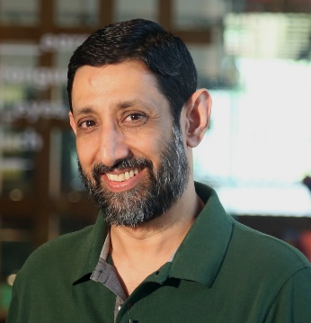
B.S., The University of Delhi
Kishore Bhargava is based in New Delhi, India. He has worked with and for
CGNET for 20 years. Kishore provides consultancy in the areas of IT
Operations, System Administration, Facility Management, Network Administration, Security, System Design, and Training Kishore managed entire IT departments (from 250-1500 users) for CGNET clients in Indonesia, Philippines, and Kenya. He has also provided on-the-ground support to many CGNET clients including Ford Foundation, Packard Foundation, Family Health International (FHI), CARE, Center for International Forestry Research,
International Rice Research Institute, International Development Research Center, International Crops Research in Semi-Arid Tropics, International Fund for Agricultural Development and many others.
Kishore is an expert contributor to several respected technology magazines and a regular presenter on a
Delhi-based technology television program, “Gadget Guru.”

Jacqueline Bilodeau, Communications Director

B.A., Stanford University, Sociology/Social Sciences
Jackie manages CGNET’s external communication streams including website design and content, social media, newsletters, blogs, media campaigns and customer relationship management systems.
Jackie returned to CGNET in 2018 after serving from 1991-2002 as the Client Support Coordinator, where she acted as a liaison between IT support staff and clients. In her current position, Jackie is responsible for the creation, production and distribution of informational and promotional materials to existing and prospective customers, administration of the CGNET
website, writing and editing blogs, and other writing and editorial activities (proposals, service contracts, human resources documents, etc.) as needed.
During her years away from CGNET as a stay-at-home mom, Jackie was very active in volunteer work involving community hunger issues. She served as the co-coordinator of a food pantry, assisting with all daily operations and management. Jackie helped modernize the 30-year-old pantry by setting up its first client database, enabling the generation of client demographics and participation statistics. She managed monthly procurement, delivery and handling of food items from the county food bank and donors, organized student and adult volunteers, wrote grant proposals and oversaw special events. She loves to travel and enjoys music, dance, movies, theatre and hiking the beautiful hills, mountains and shoreline of California.

Liliana Bravo, MCP, Senior Systems Engineer

B.S., Systems Engineering, University Nacional del Callao, Peru
Liliana has 20 years’ experience in IT. She is a Microsoft Certified Professional and a worked with Office 365, MS Windows servers, MS Azure Active Directory, MS Windows 10, Apple Mac, IOS Mobile devices, Symantec cloud security.
She has experience on various Microsoft platforms including AD. She has undertaken a dozen migrations to Office 365 and has worked on very complex AD structures of up to 12,000 people.
Prior to CGNET, Liliana worked for nine years as System Administrator of the International Potato Centre in Lima, Peru. Liliana holds Microsoft Certified Professional status in messaging, communications, and cloud services. She is fluent in Spanish and English.

Amanuel Brook, IT Consultant & Support Specialist
B.S., Computer Science, HiLCoE School of Computer Science & Technology

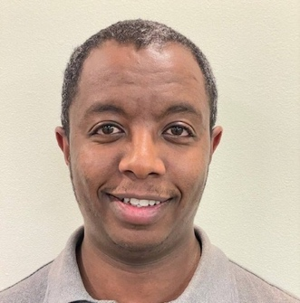
Amanuel is an IT professional with a decade of experience providing technical and help desk support. He has extensive experience working in the front-line helping clients and customers resolve simple up to complex technical IT issues. He also has experience working with IT equipment, network and communication infrastructure. Amanuel previously worked as an IT Support Specialist at the United Nations Industrial Development Organization. He now provides support to CGNET’s customers in Ethiopia.

Daniel Callahan, Vice President, Global Services

M.S. Management, MIT Sloan School of Management
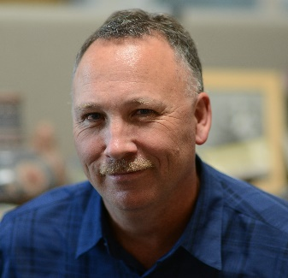
Dan is responsible for development of CGNET’s cloud and cyber security services. He oversees all aspects of CGNET’s Microsoft 365, Teams, Azure, Enterprise Mobility + Security and Dynamics 365 for Sales cloud services. He also oversees all aspects of CGNET's vulnerability testing, GDPR compliance, risk assessment and security consulting services.
In 2019, Dan authored or co-authored four working papers for the Technology Association of Grantmakers’ Cybersecurity Working Group. In 2020 Dan was a featured speaker on cybersecurity at four different conferences.
As a consultant, Dan has conducted many cybersecurity, technology planning, change management and tool selection projects for customers including the World Food Programme, Energy Foundation, PYXERA Global, the Kenneth Rainin Foundation, Lemelson Foundation, Surdna Foundation, Marin Community Foundation, the Stuart Foundation, Education Pioneers, the California Wellness Foundation, Clinica Sierra Vista, ClimateWorks Foundation, the Duke Endowment, the Ludwig Institute for Cancer Research and Carnegie Hall.
Dan served as Director of Marketing and Business Operations at CGNET from 1999 to 2003. Prior to rejoining CGNET in 2011, Dan held Director- and VP-level positions in Product Management and Marketing at iPass (acquired by Parateum), SOMA Networks, Daintree Networks (acquired by GE) and YouSendIt (acquired by OpenText). He has been responsible for product lines generating up to $100 million in revenue. Dan has more than 20 years of experience in Product Management, Product Marketing and Software Engineering in the broadband, networking, energy management, mobility, and cloud-based services industries. Dan has managed large-scale systems software projects and specified requirements for software supporting millions of concurrent user sessions. Dan’s undergraduate degree is in Anthropology from Stanford University.
Dan spends his time off doing woodworking and gardening. And fun fact: Dan wrote Chapter 5 (Analytic Methods) of CEO Georg Lindsey’s PhD thesis, in exchange for pizza and beer.

Harris Ejiofor, Information Security Engineer
B.S., Information Technology

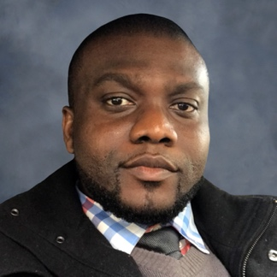
Harris brings to CGNET over a decade of experience in IT from multiple industries, with a focus on IT risk mitigation, security management, audit and regulatory compliance, project management, data management and risk remediation. He has both CompTIA Security+ and CCNA certifications.

Harris works with our customers to ensure information security risk controls are implemented and appropriately monitored. He provides information security analysis and documentation in accordance with NIST standards and develops and implements technical solutions to meet regulatory security policies. In addition, he provides network and security engineering expertise and guidance for all aspects of information assurance, applies security fixes and patches to meet client security requirements, and assess security implications of new technologies or technology upgrades to planned and existing systems.

Harris is passionate about mentoring IT professionals in cyber security practices.
Outside of work, Harris enjoys listening to security podcasts, and both watching and playing soccer. He is fluent in Igbo and English.

Abiy Alemu Eticha, IT Consultant & Support Specialist

B.S., Computer Science, HiLCoE School of Computer Science & Technology

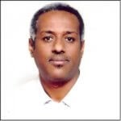
Abiy has been with CGNET for over 6 years, as a consultant on assignment for the Packard Foundation and the Bill & Melinda Gates Foundation. Abiy has been in the IT field for over 12 years and continues to gain valuable knowledge in his field and the certifications and training necessary for him to flourish as an IT Consultant & Support Specialist.

Timothy Haight, Vice President, Technology Services

Ph.D., Communication, Stanford University
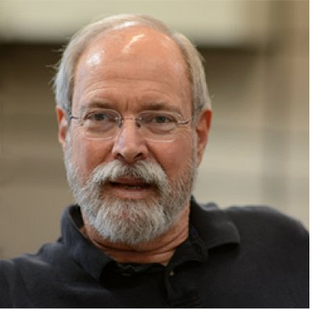
Tim has been studying how nonprofit organizations can optimize their use of information technology for more than 30 years, since he was the first evaluator for Apple Computer’s Community Affairs Program. He has been at CGNET since 2002 and conducted a great number of organizational analyses.
Tim has done assessments and strategic plans for the Marin Community Foundation, Metta Fund, the Houston Endowment, ClimateWorks Foundation, the California Wellness Foundation, the Carnegie Corporation of New York, Bush Foundation, Africa Reinsurance Corporation, Stuart Foundation, Annie E. Casey Foundation, the World Bank (CGIAR), Partners in Population and Development, FAO, the Women’s Funding Network, Britain’s Department for International Development, Canada’s International Development Research Center, the California Healthcare Foundation, the Oregon Community Foundation and the Robert Wood Johnson Foundation.

Prior to CGNET, Tim was Editor-in-Chief of FTPOnline, Vice President of Communications at OneChannel, Executive Editor of Network Computing, and West Coast Bureau Chief of CommunicationsWeek. Early in his career, Tim served on the faculties of the University of Wisconsin-Madison and California State University, Los Angeles. Tim also holds a B.A. from Stanford University.

Richard Hsu, Systems Engineer

B.S., Computer Science with Concentration in Engineering, Cal State Hayward (East Bay)
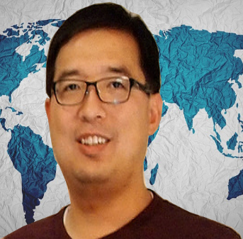
Richard specializes in network storage, routers, switches and operating systems. At CGNET, he is a part of our engineering team and supports customers worldwide. Prior to joining CGNET, Richard provided various IT services to Celeros Corporation, the California State Automobile Association and Phillips Semiconductor.

Amit Kalra, Senior IT Consultant

B.S., Math, SGTB Khalsa Collage, Delhi University
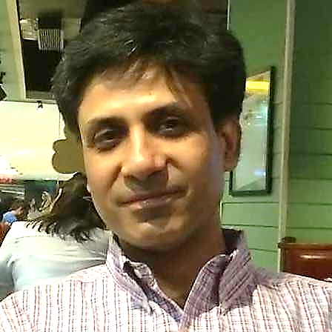
Amit Kalra has 20 years of experience in IT support. After graduating with a degree in math, he returned to school for a 2-year postgraduate program, where he obtained an advanced degree in Computers from NIIT, New Delhi.
He began his career in television as a 3D animator and video editor, and later was involved in the direction and post production of tv shows. After coming to the realization that he preferred the technical aspects of his work more than the creative, he decided to change careers and moved into IT.
His many years of on-the-ground experience include handling complete IT support for media outlets, international law firms, international institutes and various small-to-medium sized organizations. Amit has coordinated the complete IT infrastructure set-up for new offices including voice and data cabling, installation of wireless systems, firewalls, UTMs and Servers. He specializes in setting up enterprise wireless systems, SAN and NAS storage systems. He also manages cloud-based services and servers.
Amit heads a team of people who can provide efficient remote and onsite IT support in India.

Georg Lindsey, Chief Executive Officer

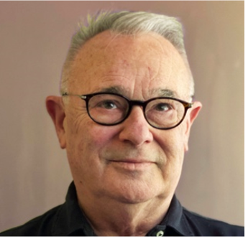
Ph.D., Communication, Stanford University
Georg co-founded CGNET in 1983 as a sustainable organization that would keep its clients at the leading edge of practical information and communication technology, with an emphasis on networking, messaging and collaboration. He has overseen and undertaken IT infrastructure designs and installations in Europe, Africa, Asia, North America, South America, and Australia. His on-the ground experience includes working with scores of international organizations and foundations including Gates Foundation, Ford Foundation, African Development Bank, UNDP, UNEP, World Bank, IFAD, USAID, US Department of Agriculture, and many more.
Prior to CGNET, Georg worked for Nortel Networks’ R & D laboratory, Bell Northern Research. Georg has undertaken consulting assignments for the Rand Corporation, SRI International, NASA, NSF, Los Alamos National Scientific Laboratories, National Institutes of Health, KQED Television, UCLA, UCBerkeley, University of Southern California, Stanford University, the Food and Drug Administration, and many others. Georg also holds a B.A. and M.A. in Communication from San Jose State University.

Dante Palacios, MCP, Global Technologies and Services Manager

B.S., Computer Science, University of Lima
Dante has 15 years of experience. He was worked with Office 365, HP servers, Netapp and Hitachi Storage, MS Windows servers, MS Azure Active Directory, MS Windows 10, Apple Mac, IOS Mobile devices, Website, DNS, Domain hosting, Symantec cloud security, Teams Voice. Dante undertakes client redesigns, upgrades and migrations to advanced platforms such as Microsoft 365, Azure, and AWS.
Prior to CGNET he worked for the International Potato Center in Lima. Dante is a VMware Certified Professional, a Microsoft Certified Professional and has undertaken continuing studies at Stanford University. He is fluent in Spanish and English.

Kadir Salami, Senior IT Consultant

M.S., Information Technology, Ladoke Akintola University of Technology

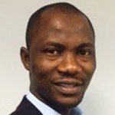
Salami provides IT management and support to CGNET clients in Africa and Europe. Salami has extensive experience in IT support and development particularly in Nigeria. He heads the consulting firm, Techspecialist
Consulting Ltd., and provides system and network administration services to the United Nations Office on Drugs and Crime, the Bill and Melinda Gates Foundation, and Quanteq Technology Services. Salami also hold a B.S. in Engineering from the University of Ilorin.

Sanni Zainab, IT Consultant & Support Specialist
BSC, Computer Science, University of Ilorin
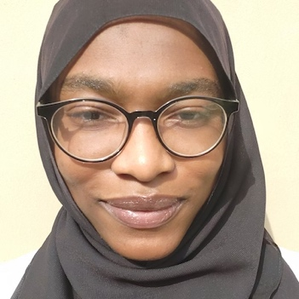
Zainab is a seasoned Network Specialist and Information System professional with several years of experience in IT. She is proficient in network, hardware, software and firewall troubleshooting and maintenance, as well as Active Directory and Office 365. She provides high quality customer support to end users and assists with policy development and IT training for staff. Zainab holds the following certificates: Cisco Certified Network Associate (CCNA), Certified Fiber Optics Technician (CFOT), Sophos Certified Engineer (SCE), Ray Certified Wi-Fi Engineer and IBG Customer Service Certification. Zainab works with CGNET at client locations in Nigeria.

Samuel Taddese, IT Consultant & Support Specialist

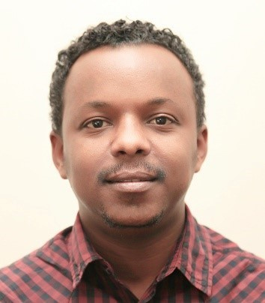
MSc. Information Systems, Addis Ababa University
Samuel has been with CGNET since February 2019 as IT Consultant and
Support Specialist on assignment at Bill & Melinda Gates Foundation and PACKARD Ethiopia Offices. In this role, Samuel coordinates IT management and supports staff. Prior to joining CGNET, Samuel was working in ILRI as an ICT Infrastructure Officer, ICT Endpoint Officer and ICT Customer Services
Officer where he acquired vast knowledge and skill in ICT support, Project Management and Systems Development. He has also worked with GOAL, USAID and a government university as IT Support, Consultant and Instructor respectively.

Lonni Ton, Administrative Associate

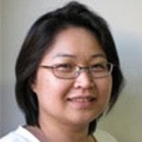
B.S., Computer Science, Sacred Heart University
Lonni is responsible for Accounts Receivable at CGNET, as well as administrative duties including travel logistics for CGNET staff.
Prior to this position, Lonni lead CGNET’s 24/7/365 team that was responsible for monitoring, troubleshooting, documenting and escalating any CGNET network-related problems. She also provided advanced technical support and was responsible for the maintenance and administration of AntiVirus, Monitoring, Documentation, and Backup systems. Before joining CGNET, Lonni owned and managed her own business and worked as a network administrator at Microphase Corporation and a PC support technician at Nash Engineering.

Ricardo Uribe, Chief Technology Officer

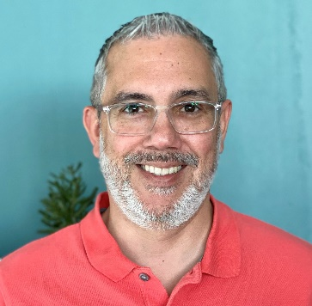
B.S., Computer Science, Oregon State University
Ricardo has overall responsibility for technology systems, design, implementation, and R&D. He is responsible for supporting CGNET clients in fifty countries.
Uribe has 30 years of experience having worked with many different technical platforms: Office 365, HP servers, Netapp and Hitachi Storage, MS Windows servers, MS Azure Active Directory, MS Windows 10, and Apple Mad, IOS Mobile devices, Website, DNS, Domain hosting, Symantec and Veritas cloud security, Cisco routers, switches, firewalls, and wireless access points, Meraki, Fortinet, and Sophos. Sonic Wall.
Ricardo has served and currently serves as the virtual Chief Technology Officer at several Silicon Valley startups and foundations including Sonitus Technologies and Metta Fund. He oversees the local IT support of the Bill and Melinda Gates Foundation offices in Beijing, New Delhi, Abuja, Addis Ababa, and Johannesburg.
He has conducted strategic ICT consulting and assessments for the World Conservation Union, Carnegie Corporation, Duke Endowment, University of the Virgin Islands, FAO, the Africa Rice Center in Cotonou, Benin, the International Institute of Tropical Agriculture in Ibadan, Nigeria, the African Development Bank, the Robert Wood Johnson Foundation, the Annie E Casey Foundation, and many others.
Ricardo joined CGNET in 1999 after working for seven years at the International Center for Tropical Agriculture (CIAT) in Colombia in the GIS department, and later in the Information Systems Unit as Network and Computer Administration Manager, User Support Manager, and Chief Information Officer.

Veronika Villarreal, Administrative Assistant

B.S. Systems Engineer, University of Lima
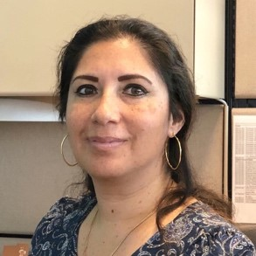
Veronika recently joined CGNET as an Administrative Assistant, working with the A/R and A/P departments as well as providing general clerical duties for the company.
Prior to CGNET, Veronika worked in Sales with Editrade and Oracle, and as an Autodesk Product Manager for Sams. She joins our team after spending several years as a stay-at-home mom and volunteer in her community. Veronika is fluent in Spanish and English.

Colin Webster, Senior Technical Advisor

B.A., Honors, Geography, Computer Studies, Edge Hill College of Higher Education – Lancaster University

Former IT director of the International Centre for Research in the Dry Areas (ICARDA) in Aleppo, Beirut, and Aman, Colin is an ICT Consultant with 25 years extensive International Information Technology knowledge and experience. He has worked with and visited a majority of the CGIAR international centers in a dozen countries. He works daily with Packard Foundation offices in Addis, Karachi, and Delhi. We recently completed an assignment for the World Food Program which involved the migration of 15,000 mailboxes from on-prem to Office 365.

Colin is a certified as Information Security Manager (CISM) by ISACA (Information Systems Audit and Control Association). He is skilled in developing and maintaining a broad vision and cultivating excellent working relationships within an organization. Colin works with clients to assess their current IT situation, delivering expert insight and robust recommendations that strengthen management decision-making.

