CGNET Team Members, in alphabetical order:

Grace Uche Alubari, IT Consultant & Support Specialist
B.Eng. in Electrical and Electronics Engineering, Federal University of Technology Owerri, Imo State, Nigeria
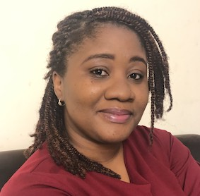
Grace has several trainings and certifications in Cloud Computing and Cyber Security, and numerous professional trainings including maintaining and troubleshooting Windows Vista Computers (MS5118), Microsoft Certified Professional MCP, Microsoft Certified Solutions Associate (MCSA) and installing and xonfiguring for Windows7 (MS70-680 and70-685) IT Infrastructure Library (ITIL V2.0).
Grace holds a Post Graduate Diploma in Project Management from the University of Liverpool and has contributed greatly to IT projects for a multinational company in the oil and gas industry. These ranged from operating systems migrations (2009), Microsoft Office Suites upgrades, software deployment and several adoptions of remote working tools -MOP, MOB, DTAO, Remote Access and Global Protect. She also worked part-time as Project Coordinator for Desk Phones to Soft Phones Migration Project (2014) across countrywide locations.
Before assuming her role with CGNET Technical Support for the Bill and Melinda Gates Foundation in Abuja, Grace worked as an IT Support Analyst for the Central Service Desk in Shell Petroleum and Development Company (SPDC) in Port-Harcourt for 11 years.
Grace is passionate about providing great customer experience, focus-driven on successful project completion. She enjoys creative writing, particularly short stories and poetry. She is an adamant believer that every human has a pot of gold in them. She speaks Igbo, Hausa and English fluently, and has a good working knowledge of ASL.
Josephine Andrews, Administrator
B.A., Accounting, Holy Cross of Davao College- Davao City, Philippines
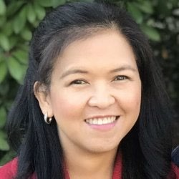
Josephine manages the business and financial activities of CGNET. These include accounting, accounts receivable, accounts payable, payroll, corporate tax, etc. She also manages employees’ medical insurance and retirement benefits.
Josephine has many years of accounting experience, working for Bank of
America Savings Bank, the Institute of Primary Health Care, Davao Light & Power Company and the Development Agency Institute, which is a non-profit organization. Josephine speaks fluent English, Tagalog and Visayan and is a valued member of our team.
Temitope Ayeni, IT Consultant & AV Specialist
B.Sc. Chemistry, Ahmadu Bello University, Zaira

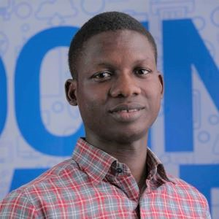
Temitope is a highly skilled IT professional with an extensive knowledge and background in IT Support, Networking, Information Security and AV Technologies. He is a Cisco Certified Network Associate and a Google Certified IT Support Professional. His experience includes support for Microsoft Teams Room-based video conferencing, Cisco Webex and integrated AV systems, such as Crestron. Beyond his focus on effective, high-quality operation of AV systems and technology, he has several years of experience with Microsoft 365, Teams, Zoom, Sharepoint, Azure, Vmware and Active Directory. Temitope works with CGNET at client locations in Nigeria. He is fluent in English and Yoruba, and enjoys reading, traveling and research..
Kishore Bhargava, Senior Technology Consultant

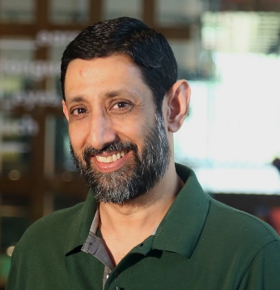
B.S., The University of Delhi
Kishore Bhargava is based in New Delhi, India. He has worked with and for
CGNET for 20 years. Kishore provides consultancy in the areas of IT
Operations, System Administration, Facility Management, Network Administration, Security, System Design, and Training Kishore managed entire IT departments (from 250-1500 users) for CGNET clients in Indonesia, Philippines, and Kenya. He has also provided on-the-ground support to many CGNET clients including Ford Foundation, Packard Foundation, Family Health International (FHI), CARE, Center for International Forestry Research,
International Rice Research Institute, International Development Research Center, International Crops Research in Semi-Arid Tropics, International Fund for Agricultural Development and many others.
Kishore is an expert contributor to several respected technology magazines and a regular presenter on a
Delhi-based technology television program, “Gadget Guru.”
Jacqueline Bilodeau, Communications Director

B.A., Stanford University, Sociology/Social Sciences
Jackie manages CGNET’s external communication streams including website design and content, social media, newsletters, blogs, media campaigns and customer relationship management systems.
Jackie returned to CGNET in 2018 after serving from 1991-2002 as the Client Support Coordinator, where she acted as a liaison between IT support staff and clients. In her current position, Jackie is responsible for the creation, production and distribution of informational and promotional materials to existing and prospective customers, administration of the CGNET
website, writing and editing blogs, and other writing and editorial activities (proposals, service contracts, human resources documents, etc.) as needed.
During her years away from CGNET as a stay-at-home mom, Jackie was very active in volunteer work involving community hunger issues. She served as the co-coordinator of a food pantry, assisting with all daily operations and management. Jackie helped modernize the 30-year-old pantry by setting up its first client database, enabling the generation of client demographics and participation statistics. She managed monthly procurement, delivery and handling of food items from the county food bank and donors, organized student and adult volunteers, wrote grant proposals and oversaw special events. She loves to travel and enjoys music, dance, movies, theatre and hiking the beautiful hills, mountains and shoreline of California.
Liliana Bravo, MCP, Senior Systems Engineer

B.S., Systems Engineering, University Nacional del Callao, Peru

Liliana has 20 years’ experience in Information Technology-related fields. She began as a system administrator managing Microsoft-based systems and assisting the helpdesk support group to troubleshoot end-user’s problems. Liliana has an expert background in Microsoft Active Directory and Exchange and helps manage Microsoft 365 for various clients. As a vital member of the CGNET consulting team, she actively takes part in various deployments from email migrations, to data center migrations to the cloud. Liliana is based in Texas and provides support to our overseas clients.
Prior to CGNET, Liliana worked for nine years as System Administrator of the International Potato Centre in Lima, Peru. Liliana holds Microsoft Certified Professional status in messaging, communications, and cloud services. She is fluent in Spanish and English.

Amanuel Brook, IT Consultant & Support Specialist

B.S., Computer Science, HiLCoE School of Computer Science & Technology
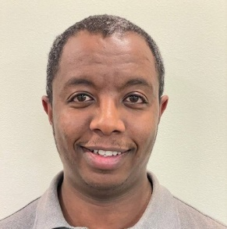
Amanuel is an IT professional with a decade of experience providing technical and help desk support. He has extensive experience working in the front-line helping clients and customers resolve simple up to complex technical IT issues. He also has experience working with IT equipment, network and communication infrastructure. Amanuel previously worked as an IT Support Specialist at the United Nations Industrial Development Organization. He now provides support to CGNET’s customers in Ethiopia.

Daniel Callahan, Senior Technical Advisor

M.S. Management, MIT Sloan School of Management
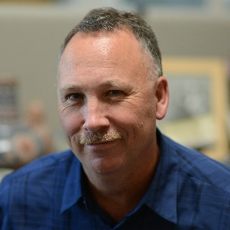
Dan developed CGNET’s cloud and cybersecurity practices and managed consulting services. Dan has been a featured speaker on cybersecurity at numerous conferences and/or webinars.

As a consultant, Dan conducted many cybersecurity, technology planning, change management and tool selection projects for customers including WT Grant Foundation, World Food Programme, Energy Foundation, PYXERA Global, Kenneth Rainin Foundation, Lemelson Foundation, Surdna Foundation, Marin Community Foundation, Stuart Foundation, Education Pioneers, the California Wellness Foundation, Heising-Simons Foundation, ClimateWorks Foundation, the Duke Endowment, the Ludwig Institute for Cancer Research and Carnegie Hall.

Prior to CGNET, he held Director- and VP-level positions at iPass, SOMA Networks, Daintree Networks, and YouSendIt. Dan has more than 20 years of experience in the broadband, networking, energy management, mobility, and cloud-based services industries.

His undergraduate degree is in Anthropology from Stanford University. Dan spends his time off doing woodworking and gardening.

Abiy Alemu Eticha, IT Consultant & Support Specialist

B.S., Computer Science, HiLCoE School of Computer Science & Technology

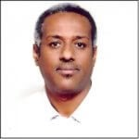
Abiy has been with CGNET for over 6 years, as a consultant on assignment for the Packard Foundation and the Bill & Melinda Gates Foundation. Abiy has been in the IT field for over 12 years and continues to gain valuable knowledge in his field and the certifications and training necessary for him to flourish as an IT Consultant & Support Specialist.

Yi-Feng (Richard) Hsu, Systems Engineer

B.S., Computer Science with Concentration in Engineering, Cal State Hayward (East Bay)
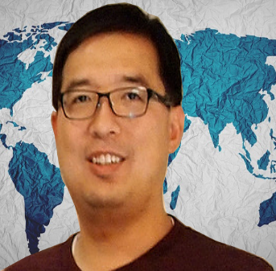
Richard has been an employee of CGNET for ten years and is a part of our engineering team. He supports domestic customers, currently Institute for the Future, Steel Perlot, Metta Fund, Zellerbach Family Foundation, IT2 and others.
Richard specializes in help desk and onsite support. He is experienced with PC-based and Apple computers. On a regular basis, he supports Microsoft 365, Google Workspaces, Azure, and AWS. Richard routinely supports firewalls, routers, switches, printers, Wi-Fi access points, Internet Access connections and audio-visual systems. He also helps the team with PowerShell scripts in Azure and Microsoft 365.
Prior to joining CGNET, Richard provided various IT services to Celeros Corporation, the California State Automobile Association and Phillips Semiconductor. He is fluent in English and Mandarin.

Amit Kalra, Senior IT Consultant

B.S., Math, SGTB Khalsa Collage, Delhi University
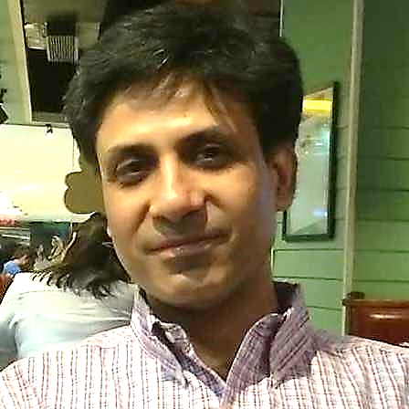
Amit Kalra has 20 years of experience in IT support. After graduating with a degree in math, he returned to school for a 2-year postgraduate program, where he obtained an advanced degree in Computers from NIIT, New Delhi.
He began his career in television as a 3D animator and video editor, and later was involved in the direction and post production of tv shows. After coming to the realization that he preferred the technical aspects of his work more than the creative, he decided to change careers and moved into IT.
His many years of on-the-ground experience include handling complete IT support for media outlets, international law firms, international institutes and various small-to-medium sized organizations. Amit has coordinated the complete IT infrastructure set-up for new offices including voice and data cabling, installation of wireless systems, firewalls, UTMs and Servers. He specializes in setting up enterprise wireless systems, SAN and NAS storage systems. He also manages cloud-based services and servers.
Amit heads a team of people who can provide efficient remote and onsite IT support in India.

Georg Lindsey, Chief Executive Officer
Ph.D., Communication, Stanford University
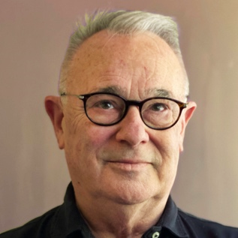
Georg co-founded CGNET in 1983 as a sustainable organization that would keep its clients at the leading edge of practical information and communication technology, with an emphasis on networking, messaging and collaboration. He has overseen and undertaken IT infrastructure designs and installations in Europe, Africa, Asia, North America, South America, and Australia. His on-the ground experience includes working with scores of international organizations and foundations including Gates Foundation, Ford Foundation, African Development Bank, UNDP, UNEP, World Bank, IFAD, USAID, US Department of Agriculture, and many more.
Prior to CGNET, Georg worked for Nortel Networks’ R & D laboratory, Bell Northern Research. Georg has undertaken consulting assignments for the Rand Corporation, SRI International, NASA, NSF, Los Alamos National Scientific Laboratories, National Institutes of Health, KQED Television, UCLA, UCBerkeley, University of Southern California, Stanford University, the Food and Drug Administration, and many others. Georg also holds a B.A. and M.A. in Communication from San Jose State University.

Dante Palacios, MCP, Global Technologies and Services Manager

B.S., Computer Science, University of Lima
Dante has over 20 years of experience working in the Information Technology field with a strong background in Microsoft products like Active Directory, Exchange and Microsoft 365. His experience is not only with software, but also with managing data centers using hardware of different flavors, such as Dell and HPE servers and Netapp-based file servers. He has managed many migration-to-cloud projects and is part of the 3rd level escalation team at CGNET. Because of all this, he also has experience with networking. Dante has worked in projects related to Azure and AWS deployments and is an active member of the CGNET Security services team.
Prior to CGNET he worked for the International Potato Center in Lima. Dante is a VMware Certified Professional, a Microsoft Certified Professional and has undertaken studies at Stanford University. He is fluent in Spanish and English.

Kadir Salami, Senior IT Consultant

M.S., Information Technology, Ladoke Akintola University of Technology

Salami provides IT management and support to CGNET clients in Africa and Europe. Salami has extensive experience in IT support and development particularly in Nigeria. He heads the consulting firm, Techspecialist
Consulting Ltd., and provides system and network administration services to the United Nations Office on Drugs and Crime, the Bill and Melinda Gates Foundation, and Quanteq Technology Services. Salami also hold a B.S. in Engineering from the University of Ilorin.

Samuel Taddese, IT Consultant & Support Specialist

MSc. Information Systems, Addis Ababa University
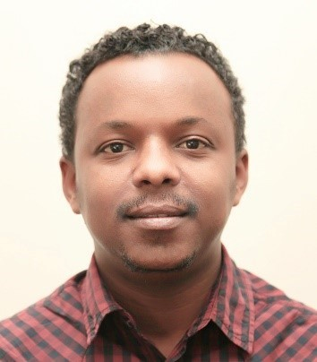
Samuel has been with CGNET since February 2019 as IT Consultant and
Support Specialist on assignment at Bill & Melinda Gates Foundation and PACKARD Ethiopia Offices. In this role, Samuel coordinates IT management and supports staff. Prior to joining CGNET, Samuel was working in ILRI as an ICT Infrastructure Officer, ICT Endpoint Officer and ICT Customer Services
Officer where he acquired vast knowledge and skill in ICT support, Project Management and Systems Development. He has also worked with GOAL, USAID and a government university as IT Support, Consultant and Instructor respectively.

Lonni Ton, Administrative Associate

B.S., Computer Science, Sacred Heart University
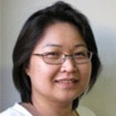
Lonni is responsible for Accounts Receivable at CGNET, as well as administrative duties including travel logistics for CGNET staff.
Prior to this position, Lonni lead CGNET’s 24/7/365 team that was responsible for monitoring, troubleshooting, documenting and escalating any CGNET network-related problems. She also provided advanced technical support and was responsible for the maintenance and administration of AntiVirus, Monitoring, Documentation, and Backup systems. Before joining CGNET, Lonni owned and managed her own business and worked as a network administrator at Microphase Corporation and a PC support technician at Nash Engineering.

Ricardo Uribe, Chief Technology Officer

B.S., Computer Science, Oregon State University
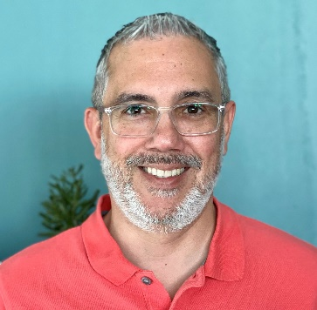
Ricardo has overall responsibility for technology systems, design, implementation, and R&D. He is responsible for supporting CGNET clients in fifty countries.
Uribe has 30 years of experience having worked with many different technical platforms: Office 365, HP servers, Netapp and Hitachi Storage, MS Windows servers, MS Azure Active Directory, MS Windows 10, and Apple Mad, IOS Mobile devices, Website, DNS, Domain hosting, Symantec and Veritas cloud security, Cisco routers, switches, firewalls, and wireless access points, Meraki, Fortinet, and Sophos. Sonic Wall.
Ricardo has served and currently serves as the virtual Chief Technology Officer at several Silicon Valley startups and foundations including Sonitus Technologies and Metta Fund. He oversees the local IT support of the Bill and Melinda Gates Foundation offices in Beijing, New Delhi, Abuja, Addis Ababa, and Johannesburg.
He has conducted strategic ICT consulting and assessments for the World Conservation Union, Carnegie Corporation, Duke Endowment, University of the Virgin Islands, FAO, the Africa Rice Center in Cotonou, Benin, the International Institute of Tropical Agriculture in Ibadan, Nigeria, the African Development Bank, the Robert Wood Johnson Foundation, the Annie E Casey Foundation, and many others.
Ricardo joined CGNET in 1999 after working for seven years at the International Center for Tropical Agriculture (CIAT) in Colombia in the GIS department, and later in the Information Systems Unit as Network and Computer Administration Manager, User Support Manager, and Chief Information Officer.

Victoria Ubi, IT Consultant and Support Specialist

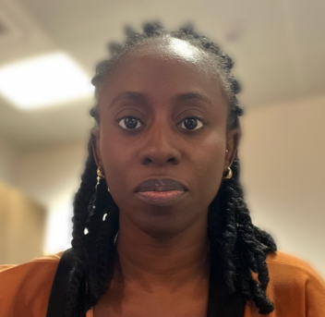
Victoria, an accomplished O365 professional, brings a wealth of experience in the IT domain. Experience with Microsoft 365 components and services, spanning various branches such as productivity applications (Word, Excel, PowerPoint, Outlook, OneNote, Access, Publisher), communication and collaboration tools (Microsoft Teams, Exchange Online, SharePoint Online, OneDrive for Business), cloud services (Azure Active Directory, Azure Information Protection), security and compliance solutions (Microsoft Defender for Office 365, Microsoft Compliance Center), enterprise mobility and security features (Azure Active Directory Premium, Intune, Azure Information Protection
She showcases competence in identifying and resolving issues with both hardware and software, as well as effectively maintaining them.
Currently collaborating with CGNET, Victoria applies her expertise at client locations in Nigeria, ensuring optimal performance and reliability in IT systems.

Veronika Villarreal, Administrative Assistant

B.S. Systems Engineer, University of Lima
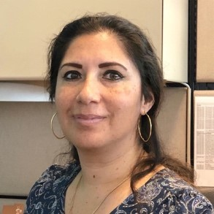
Veronika recently joined CGNET as an Administrative Assistant, working with the A/R and A/P departments as well as providing general clerical duties for the company.
Prior to CGNET, Veronika worked in Sales with Editrade and Oracle, and as an Autodesk Product Manager for Sams. She joins our team after spending several years as a stay-at-home mom and volunteer in her community. Veronika is fluent in Spanish and English.

Lanre Yusuf, Senior IT Consultant
Senior IT Consultant
Project Management Professional (PMP), Project Management Institute
Lanre provides IT management and support to CGNET clients in Africa. With over 12 years’ experience managing IT projects, he is responsible for delivering successful IT projects within and outside Nigeria. He is a Managing Director and the Team Lead at the Nigeria-based IT firm Techspecialist Consulting Ltd. Lanre has lead a team of 20 professionals that has helped various organizations design their technology roadmap, implement systems that are cost-effective, and ensure they are cyber secure and future-proof. He and his team are dedicated to providing top-notch IT support to an organization's staff, no matter where they are based in the world. Lanre has achieved multiple certifications, including IT Service Management, Professional Scrum Master, and Microsoft Dynamics, in addition to his Master’s Degree in Mass Communication from National Open University in Abuja.

Sanni Zainab, IT Consultant & Support Specialist
BSC, Computer Science, University of Ilorin
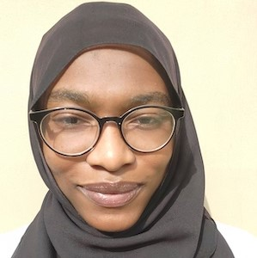
Zainab is a seasoned Network Specialist and Information System professional with several years of experience in IT. She is proficient in network, hardware, software and firewall troubleshooting and maintenance, as well as Active Directory and Office 365. She provides high quality customer support to end users and assists with policy development and IT training for staff. Zainab holds the following certificates: Cisco Certified Network Associate (CCNA), Certified Fiber Optics Technician (CFOT), Sophos Certified Engineer (SCE), Ray Certified Wi-Fi Engineer and IBG Customer Service Certification. Zainab works with CGNET at client locations in Nigeria..

