

CGNET Team Members, in alphabetical order:

Josephine Andrews, Administrator
B.A., Accounting, Holy Cross of Davao College- Davao City, Philippines
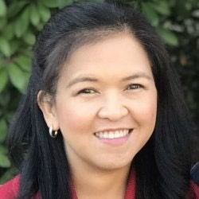
Josephine manages the business and financial activities of CGNET. These include accounting, accounts receivable, accounts payable, payroll, corporate tax, etc. She also manages employees’ medical insurance and retirement benefits.
Josephine has many years of accounting experience, working for Bank of
America Savings Bank, the Institute of Primary Health Care, Davao Light & Power Company and the Development Agency Institute, which is a non-profit organization. Josephine speaks fluent English, Tagalog and Visayan and is a valued member of our team.

Godwin Arigbonu, Senior IT Consultant
MBA, Finance & Investment

Godwin provides IT management and support to CGNET clients in Africa. He is the Managing Director and the Team Lead at the Nigeria-based IT firm Techspecialist Consulting Ltd. Godwin has 16 years of executive leadership experience and he has established himself as a strategic business leader with exceptional expertise in digital transformation, business intelligence, and government relations.
Prior to joining Techspecialist Consulting, he served as Chief Business and Strategy Officer at Hyperdrive Technology Limited where he orchestrated significant public and private sector IT transformation initiatives. He had also worked as the Chief Commercial Officer at Suburban Fiber Company, where he demonstrated his commercial acumen by cultivating strategic partnerships that championed innovative GovTech initiatives for various federal agencies.
Godwin holds an MBA in Finance & Investment and an Advanced Diploma in Business Process Management. His professional training includes certifications in Strategic Key Account Management, Digital Transformation Leadership, Business Analysis, and Information Systems Auditing.

Temitope Ayeni, IT Consultant & AV Specialist
B.Sc. Chemistry, Ahmadu Bello University, Zaira

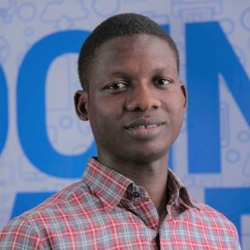
Temitope is a highly skilled IT professional with an extensive knowledge and background in IT Support, Networking, Information Security and AV Technologies. He is a Cisco Certified Network Associate and a Google Certified IT Support Professional. His experience includes support for Microsoft Teams Room-based video conferencing, Cisco Webex and integrated AV systems, such as Crestron. Beyond his focus on effective, high-quality operation of AV systems and technology, he has several years of experience with Microsoft 365, Teams, Zoom, Sharepoint, Azure, Vmware and Active Directory. Temitope works with CGNET at client locations in Nigeria. He is fluent in English and Yoruba, and enjoys reading, traveling and research.
Kishore Bhargava, Senior Technology Consultant

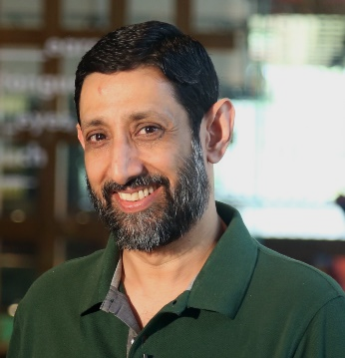
B.S., The University of Delhi
Kishore is responsible for System Administration, Facility Management, Network Administration, Security, System Design, and Training. He has covered several regions for CGNET, including South and South-East Asia, East and West Africa, USA and China. Kishore managed entire IT departments (from 250-1500 users) for CGNET clients in Indonesia, Philippines, and Kenya. He has also provided on-the-ground support to many of CGNET clients including the Ford Foundation, Packard Foundation, Family Health International (FHI), CARE, Center for International Forestry Research, International Rice Research Institute, International Development Research Center, International Crops Research in Semi-Arid Tropics, International Fund for Agricultural Development and many others.

Outside his work with CGNET, Kishore is also a contributor to a domestic newspaper, and describes himself as a “confirmed geek, wanna-be photographer, perpetual learner, FOSS fanboy, and aspiring coffee snob”. He is fluent in both English and Hindi.

Jacqueline Bilodeau, Communications Director

B.A., Stanford University, Sociology/Social Sciences

Jackie manages CGNET’s external communication streams including website design and content, social media, newsletters, blogs, media campaigns, project documentation, project reporting and customer relationship management.
Jackie rejoined CGNET in 2018, having previously served as Client Support Coordinator from 1991 to 2002, where she liaised between IT support and clients. Currently, she manages the creation and distribution of informational and promotional content, oversees the CGNET website, writes and edits blogs, and handles various editorial tasks, including proposals, service contracts, and HR documents.
During her time away from CGNET as a stay-at-home mom, Jackie actively volunteered in addressing community hunger issues. She co-coordinated a food pantry, modernizing its operations by establishing the first client database to track demographics and participation. Jackie managed food procurement and delivery, organized volunteers, wrote grant proposals, and oversaw special events.

Liliana Bravo, MCP, Senior Systems Engineer

B.S., Systems Engineering, University Nacional del Callao, Peru

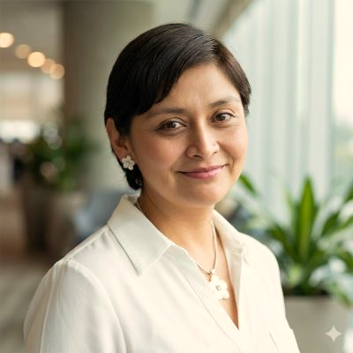
Liliana has over 20 years’ experience in Information Technology-related fields. She began as a system administrator managing Microsoft-based systems and assisting the helpdesk support group to troubleshoot end-user’s problems. Liliana has an expert background in Microsoft Active Directory and Exchange and helps manage Microsoft 365 for various clients. As a vital member of the CGNET consulting team, she actively takes part in various deployments from email migrations, to data center migrations to the cloud. Liliana is based in Texas and provides support to our overseas clients.
Prior to CGNET, Liliana worked for nine years as System Administrator of the International Potato Centre in Lima, Peru. Liliana holds Microsoft Certified Professional status in messaging, communications, and cloud services. She is fluent in Spanish and English.

Amanuel Brook, IT Consultant & Support Specialist

B.S., Computer Science, HiLCoE School of Computer Science & Technology
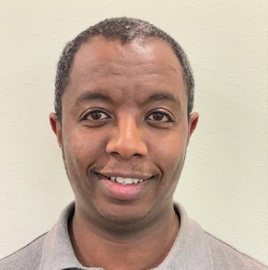
Amanuel is an IT professional with a decade of experience providing technical and help desk support. He has extensive experience working in the front-line helping clients and customers resolve simple up to complex technical IT issues. He also has experience working with IT equipment, network and communication infrastructure. Amanuel previously worked as an IT Support Specialist at the United Nations Industrial Development Organization. He now provides support to CGNET’s customers in Ethiopia.

Daniel Callahan, Senior Technical Consultant

M.S. Management, MIT Sloan School of Management
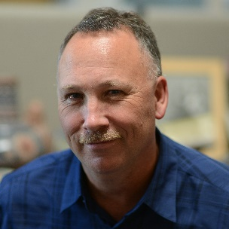
Dan developed CGNET’s cloud and cybersecurity practices and managed consulting services. Dan has been a featured speaker on cybersecurity at numerous conferences and/or webinars.

As a consultant, Dan conducted many cybersecurity, technology planning, change management and tool selection projects for customers including WT Grant Foundation, World Food Programme, Energy Foundation, PYXERA Global, Kenneth Rainin Foundation, Lemelson Foundation, Surdna Foundation, Marin Community Foundation, Stuart Foundation, Education Pioneers, the California Wellness Foundation, Heising-Simons Foundation, ClimateWorks Foundation, the Duke Endowment, the Ludwig Institute for Cancer Research and Carnegie Hall.

Prior to CGNET, he held Director- and VP-level positions at iPass, SOMA Networks, Daintree Networks, and YouSendIt. Dan has more than 20 years of experience in the broadband, networking, energy management, mobility, and cloud-based services industries.

His undergraduate degree is in Anthropology from Stanford University. Dan spends his time off doing woodworking and gardening.
Abiy Alemu Eticha, IT Consultant & Support Specialist

B.S., Computer Science, HiLCoE School of Computer Science & Technology
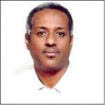
Abiy has been with CGNET for over 6 years, as a consultant on assignment for the Packard Foundation and the Bill & Melinda Gates Foundation. Abiy has been in the IT field for over 12 years and continues to gain valuable knowledge in his field and the certifications and training necessary for him to flourish as an IT Consultant & Support Specialist.

Yi-Feng (Richard) Hsu, Systems Engineer

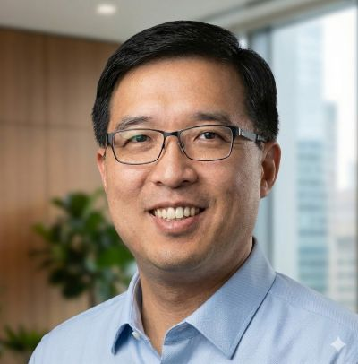
B.S., Computer Science with Concentration in Engineering, Cal State Hayward (East Bay)
Richard has been with CGNET for over ten years as a part of our engineering team. He supports domestic customers, currently Institute for the Future, Steel Perlot, Metta Fund, Zellerbach Family Foundation, IT2 and others.
Richard specializes in help desk and onsite support. He is experienced with PC-based and Apple computers. On a regular basis, he supports Microsoft 365, Google Workspaces, Azure, and AWS. Richard routinely supports firewalls, routers, switches, printers, Wi-Fi access points, Internet Access connections and audio-visual systems. He also helps the team with PowerShell scripts in Azure and Microsoft 365.
Prior to joining CGNET, Richard provided various IT services to Celeros Corporation, the California State Automobile Association and Phillips Semiconductor. He is fluent in English and Mandarin.

Amit Kalra, Senior IT Consultant

B.S., Math, SGTB Khalsa Collage, Delhi University
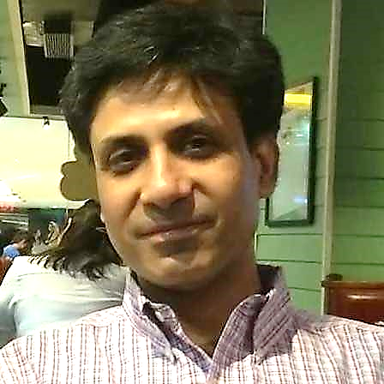
Amit Kalra has over 20 years of experience in IT support. After graduating with a degree in math, he returned to school for a 2-year postgraduate program, where he obtained an advanced degree in Computers from NIIT, New Delhi.
He began his career in television as a 3D animator and video editor and later was involved in the direction and post production of tv shows. After coming to the realization that he preferred the technical aspects of his work more than the creative, he decided to change careers and moved into IT.
His many years of on-the-ground experience include handling complete IT support for media outlets, international law firms, international institutes and various small-to-medium sized organizations. Amit has coordinated the complete IT infrastructure set-up for new offices including voice and data cabling, installation of wireless systems, firewalls, UTMs and Servers. He specializes in setting up enterprise wireless systems, SAN and NAS storage systems. He also manages cloud-based services and servers.
Amit heads a team of people who can provide efficient remote and onsite IT support in India.
Georg Lindsey, Chief Executive Officer
Ph.D., Communication, Stanford University
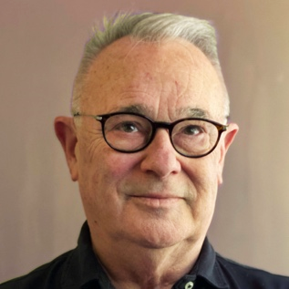
Georg co-founded CGNET in 1983 as a sustainable organization dedicated to keeping clients at the forefront of information and communication technology, with a focus on networking, messaging, and collaboration. He now leads efforts to help customers utilize Artificial Intelligence, including proficiency in tools like ChatGPT, Google Gemini, Microsoft Copilot, and Perplexity.
His extensive hands-on experience includes work with numerous international organizations and foundations, such as the Gates Foundation, Ford Foundation, African Development Bank, UNDP, UNEP, World Bank, IFAD, USAID, and the U.S. Department of Agriculture, among many others.
Before founding CGNET, Georg worked in the R&D laboratory at Nortel Networks’ Bell Northern Research. He has also undertaken consulting assignments for prominent organizations, including KQED Television, NASA, NSF, Chase Manhattan Bank, Bank of America, Rand Corporation, SRI International, Los Alamos National Laboratory, the National Institutes of Health, UCLA, UC Berkeley, the University of Southern California, Stanford University
Georg’s pre-Stanford academic career began at Rhodes College in Memphis and continued at San Jose City College and San Jose State University, where he earned a B.A. and M.A. in Communication.
A lifelong photographer, Georg has worked as a still photographer for independent film productions in Egypt, Greece, and Turkey. He often spends weekends on the California coast, observing and photographing marine creatures, seascapes, and landscapes.

Ian McCullough, IT Support Intern

B.S., Applied Cybersecurity, University of North Carolina, Wilmington

Ian joined CGNET in 2025 as an intern with our IT Support Team. Along with his cybersecurity degree, he holds certifications in LetsDefend and Picus Purple MITRE ATT&CK, and is working toward his certification in CompTIA Security+. His skills include network security, malware analysis, digital forensics, vulnerability assessments, incident response and security monitoring.

Dante Palacios, MCP, Global Technologies and Services Director

B.S., Computer Science, University of Lima

Dante has over 20 years of experience in Information Technology, with a strong background in Microsoft products, including Active Directory, Exchange, and Microsoft 365. He is also highly experienced in Google-based systems. Dante has led numerous cloud migration projects and serves on CGNET's third-level escalation team. His broad expertise extends to networking, and he has participated in Azure and AWS deployment projects. Additionally, Dante is an active member of CGNET's Security Services team.
Prior to CGNET he worked for the International Potato Center in Lima. Dante is a VMware Certified Professional, a Microsoft Certified Professional and has undertaken studies at Stanford University. He is fluent in Spanish and English.

Kadir Salami, Senior IT Consultant

M.S., Information Technology, Ladoke Akintola University of Technology
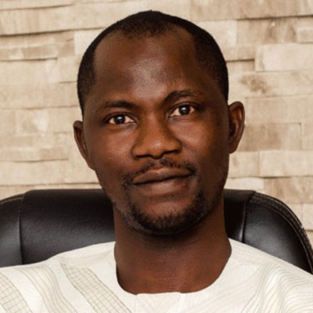
Salami provides IT management and support to CGNET clients in Africa and Europe. Salami has extensive experience in IT support and development particularly in Nigeria. He heads the consulting firm, Techspecialist
Consulting Ltd., and provides system and network administration services to the United Nations Office on Drugs and Crime, the Bill and Melinda Gates Foundation, and Quanteq Technology Services. Salami also hold a B.S. in Engineering from the University of Ilorin.

Matt Sharp, Senior Technical Consultant

B.A., Asian Languages, Stanford University

Matt is a Senior Technology Consultant at CGNET Services International, where he advises mission-driven organizations on technology strategy, governance, and the effective use of digital systems to support institutional goals.
Matt brings deep experience from the philanthropic and nonprofit sectors. Prior to joining CGNET, he served as the IT Director of The Duke Endowment, where he worked closely with program and operations teams to align technology, data, and processes with organizational priorities. His work emphasized practical, sustainable solutions that supported grantmaking, reporting, and internal collaboration.
Earlier in his career, he held roles with SITIA and the David and Lucile Packard Foundation, gaining broad exposure to foundation operations, stakeholder engagement, and the challenges of managing complex technology environments in large, distributed organizations. Across these roles, he developed a reputation for combining subject-matter expertise with a thoughtful, collaborative approach to change.
Matt is valued for his ability to translate organizational needs into actionable technology recommendations, bridging the gap between leadership, staff, and technical teams. His work focuses on helping organizations make informed decisions about systems, data, and governance — always with an eye toward mission impact, usability, and long-term resilience.

Samuel Taddese, IT Consultant & Support Specialist
MSc. Information Systems, Addis Ababa University
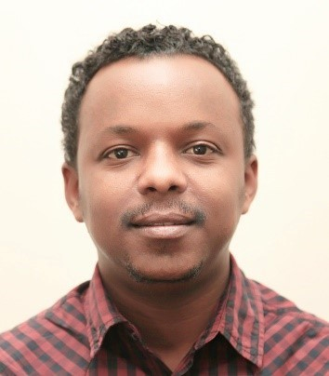
Samuel has been with CGNET since February 2019 as IT Consultant and
Support Specialist on assignment at Bill & Melinda Gates Foundation and PACKARD Ethiopia Offices. In this role, Samuel coordinates IT management and supports staff. Prior to joining CGNET, Samuel was working in ILRI as an ICT Infrastructure Officer, ICT Endpoint Officer and ICT Customer Services
Officer where he acquired vast knowledge and skill in ICT support, Project Management and Systems Development. He has also worked with GOAL, USAID and a government university as IT Support, Consultant and Instructor respectively.

Lonni Ton, Administrative Associate

B.S., Computer Science, Sacred Heart University
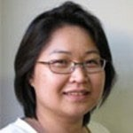
Lonni is responsible for Accounts Receivable at CGNET, as well as administrative duties including travel logistics for CGNET staff.
Prior to this position, Lonni lead CGNET’s 24/7/365 team that was responsible for monitoring, troubleshooting, documenting and escalating any CGNET network-related problems. She also provided advanced technical support and was responsible for the maintenance and administration of AntiVirus, Monitoring, Documentation, and Backup systems. Before joining CGNET, Lonni owned and managed her own business and worked as a network administrator at Microphase Corporation and a PC support technician at Nash Engineering.

Ricardo Uribe, Chief Technology Officer

B.S., Computer Science, Oregon State University
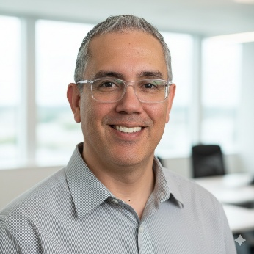
Ricardo is an experienced technology leader with comprehensive oversight in technology systems, R&D, and IT support for CGNET’s global clients. With expertise spanning major platforms, cybersecurity, and networking, he serves as virtual CTO for various Silicon Valley startups and oversees IT for high-profile foundations. His background includes roles at CIAT in Colombia, where he advanced from working in IT with the GIS group to CIO of the organization.
He has 30 years of experience having worked with many different technical platforms and hardware options, including Office 365, Google, Linux, MS Azure Active Directory, MS Windows 11, Apple Mac, IOS Mobile devices, Website, DNS, Domain hosting, Symantec and Veritas cloud security, Cisco routers, switches, firewalls, Meraki, Fortinet, Sophos, and Sonic Wall.
He has conducted strategic ICT consulting and assessments for the World Conservation Union, Carnegie Corporation, Duke Endowment, University of the Virgin Islands, FAO, the Africa Rice Center in Cotonou, Benin, the International Institute of Tropical Agriculture in Ibadan, Nigeria, the African Development Bank, the Robert Wood Johnson Foundation, the Annie E Casey Foundation, Oceans5, and many others.

Victoria Ubi, IT Consultant and Support Specialist

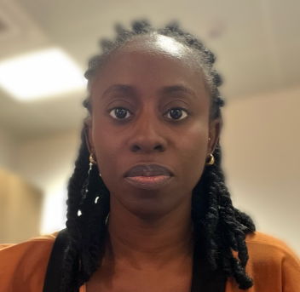
Victoria, an accomplished O365 professional, brings a wealth of experience in the IT domain. Experience with Microsoft 365 components and services, spanning various branches such as productivity applications (Word, Excel, PowerPoint, Outlook, OneNote, Access, Publisher), communication and collaboration tools (Microsoft Teams, Exchange Online, SharePoint Online, OneDrive for Business), cloud services (Azure Active Directory, Azure Information Protection), security and compliance solutions (Microsoft Defender for Office 365, Microsoft Compliance Center), enterprise mobility and security features (Azure Active Directory Premium, Intune, Azure Information Protection
She showcases competence in identifying and resolving issues with both hardware and software, as well as effectively maintaining them.
Currently collaborating with CGNET, Victoria applies her expertise at client locations in Nigeria, ensuring optimal performance and reliability in IT systems.
Veronika Villarreal, Administrative Assistant
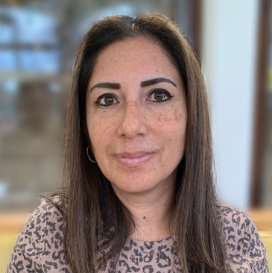
B.S. Systems Engineer, University of Lima
Veronika is CGNET’s Administrative Assistant, working with the A/R and A/P departments as well as providing general clerical duties for the company. Prior to CGNET, Veronika worked in Sales with Editrade and Oracle, and as an Autodesk Product Manager for Sams. She joined the CGNET team after working for several years as a stay-at-home mom and volunteer in her community. She is fluent in English and Spanish.

Sanni Zainab, IT Consultant & Support Specialist
BSC, Computer Science, University of Ilorin
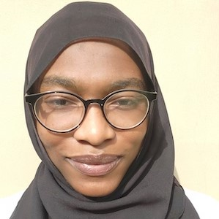
Zainab is a seasoned Network Specialist and Information System professional with several years of experience in IT. She is proficient in network, hardware, software and firewall troubleshooting and maintenance, as well as Active Directory and Office 365. She provides high quality customer support to end users and assists with policy development and IT training for staff. Zainab holds the following certificates: Cisco Certified Network Associate (CCNA), Certified Fiber Optics Technician (CFOT), Sophos Certified Engineer (SCE), Ray Certified Wi-Fi Engineer and IBG Customer Service Certification. Zainab works with CGNET at client locations in Nigeria.

